**\*Front cover** - 写日期

**About this program**

File Name : LimEnXi.c

Submit by : Google Classroom

**// Declaration of Originality** - 拿回上面的名字日期 + 照片

**Table of content** - Add page num

**Purpose**

During the covid-19 pandemic,the local authority needs to efficiently keep track of data regarding the disease cases. A basic Covid-19 Cases Tracking System is developed to enable the local authority to store cases data efficiently, and at the end of the day or session produce daily Report or an overall summary respectively for analysis. This system is open to the public, this system allow users to update new cases and read the daily report.

**//Structure chart** - paste

**//Flowchart** - paste

**Added features**

Menu - a selection menu , allow users to choose reports and update cases

User understand the steps of choosing report clearly

Display menu after the user finish update new cases

Validation - a check function , check the users inputs in proper logical

To get more accurate inputs

Bring correct information to public

Check validation when user input the number of cases

**Run scenario**

prev - 9 100 2 10 88 2.0 10.0 88.0

prev - 19 100 2 12 86 2.00 12.00 86.00

prev -

**//Table of Constants & Variables**

#define PREV_DAY 9

#define PREV_CASE 9

#define PREV_TOTAL 100

#define PREV_DEATH 2

#define PREV_RECOVER 10

#define PREV_UNDER_TREATMENT 88

#define PREV_DEATH_RATE 2.0

#define PREV_RECOVER_RATE 10.0

#define PREV_TREATMENT_RATE 88.0

char contChoice;

double compDeathRate;

double compRecoverRate;

double deathRateDiff;

double recoverRateDiff;

double prevDeathRate = PREV_DEATH_RATE;

double prevRecoverRate = PREV_RECOVER_RATE;

double prevTreatmentRate = PREV_TREATMENT_RATE;

double summDeathRate;

double summRecoverRate;

double summTreatmentRate;

int caseDiff;

int choice = 1;

int choice;

int compCase;

int compDeath;

int compRecover;

int compTotCase;

int currCase;

int currDeath;

int currImp;

int currImported;

int currLcl;

int currLocal;

int currRecover;

int day;

int dayRecord = 0;

int difference;

int highestCases = PREV_CASE;

int highestDay = PREV_DAY;

int lowestCases = PREV_CASE;

int lowestDay = PREV_DAY;

int prevCase = PREV_CASE;

int prevDay = PREV_DAY;

int prevDeath = PREV_DEATH;

int prevRecover = PREV_RECOVER;

int prevTotal = PREV_TOTAL;

int prevUnderTreatment = PREV_UNDER_TREATMENT;

int summCase;

int summDeath;

int summImported;

int summLocal;

int summRecover;

int summTotCase;

int summUnderTreatment;

int totCaseDiff;

|  |  |  |
| --- | --- | --- |
| Constant | Value | Purpose |
| PREV_DAY | 9 | To fix the previous day |
| PREV_CASE | 9 | To fix the previous cases |
| PREV_TOTAL | 100 | To fix the previous total cases |
| PREV_DEATH | 2 | To fix the previous death cases |
| PREV_RECOVER | 10 | To fix the previous recover cases |
| PREV_UNDER_TREATMENT | 88 | To fix the previous under treatment cases |
| PREV_DEATH_RATE | 2.0 | To fix the rate of previous death cases |
| PREV_RECOVER_RATE | 10.0 | To fix the rate of previous recover cases |
| PREV_TREATMENT_RATE | 88.0 | To fix the rate of previous under treatment cases |

|  |  |  |
| --- | --- | --- |
| Variables | Data Type | Purpose |
| contChoice | char | To hold the value of choice |
| compDeathRate | double | To hold the value of death cases rate |
| compRecoverRate | double | To hold the value of recover cases rate |
| deathRateDiff | double | To hold the value difference of death rate |
| recoverRateDiff | double | To hold the value difference of recover rate |
| prevDeathRate | double | To hold the value of previous death cases rate |
| prevRecoverRate | double | To hold the value of previous recover cases rate |
| prevTreatmentRate | double | To hold the value of previous treating cases rate |
| summDeathRate | double | To hold the value of death cases rate |
| summRecoverRate | double | To hold the value of recover cases rate |
| summTreatmentRate | double | To hold the value of treating cases rate |
| caseDiff | int | To hold the value difference of infected cases |
| choice | int | To hold the value of menu choice |
| choice | int | To hold the value of menu choice |
| compCase | int | To hold the value of infected cases |
| compDeath | int | To hold the value of death cases |
| compRecover | int | To hold the value of recover cases |
| compTotCase | int | To hold the value of total cases |
| currCase | int | To hold the value of infected cases |
| currDeath | int | To hold the value of death cases |
| currImp | int | To hold the value of current imported cases |
| currImported | int | To hold the value of infected imported cases |
| currLcl | int | To hold the value of current local cases |
| currLocal | int | To hold the value of infected local cases |
| currRecover | int | To hold the value of recover cases |
| day | int | To hold the value of day |
| dayRecord | Int | To hold the value of day recorded |
| difference | int | To hold the value of difference |
| highestCases | int | To hold the value of the highest cases |
| highestDay | int | To hold the value of day of the highest cases |
| lowestCases | int | To hold the value of the lowest cases |
| lowestDay | int | To hold the value of day of the lowest cases |
| prevCase | int | To hold the value of previous cases |
| prevDay | int | To hold the value of previous day |
| prevDeath | int | To hold the value of previous death cases |
| prevRecover | int | To hold the value of previous recover cases |
| prevTotal | int | To hold the value of previous total cases |
| prevUnderTreatment | int | To hold the value of previous treating cases |
| summCase | int | To hold the value of infected cases |
| summDeath | int | To hold the value of death cases |
| summImported | int | To hold the value of infected imported cases |
| summLocal | int | To hold the value of infected local cases |
| summRecover | int | To hold the value of recover cases |
| summTotCase | int | To hold the value of total cases |
| summUnderTreatment | int | To hold the value of treating cases |
| totCaseDiff | int | To hold the value difference of total cases |

**Flowchart**

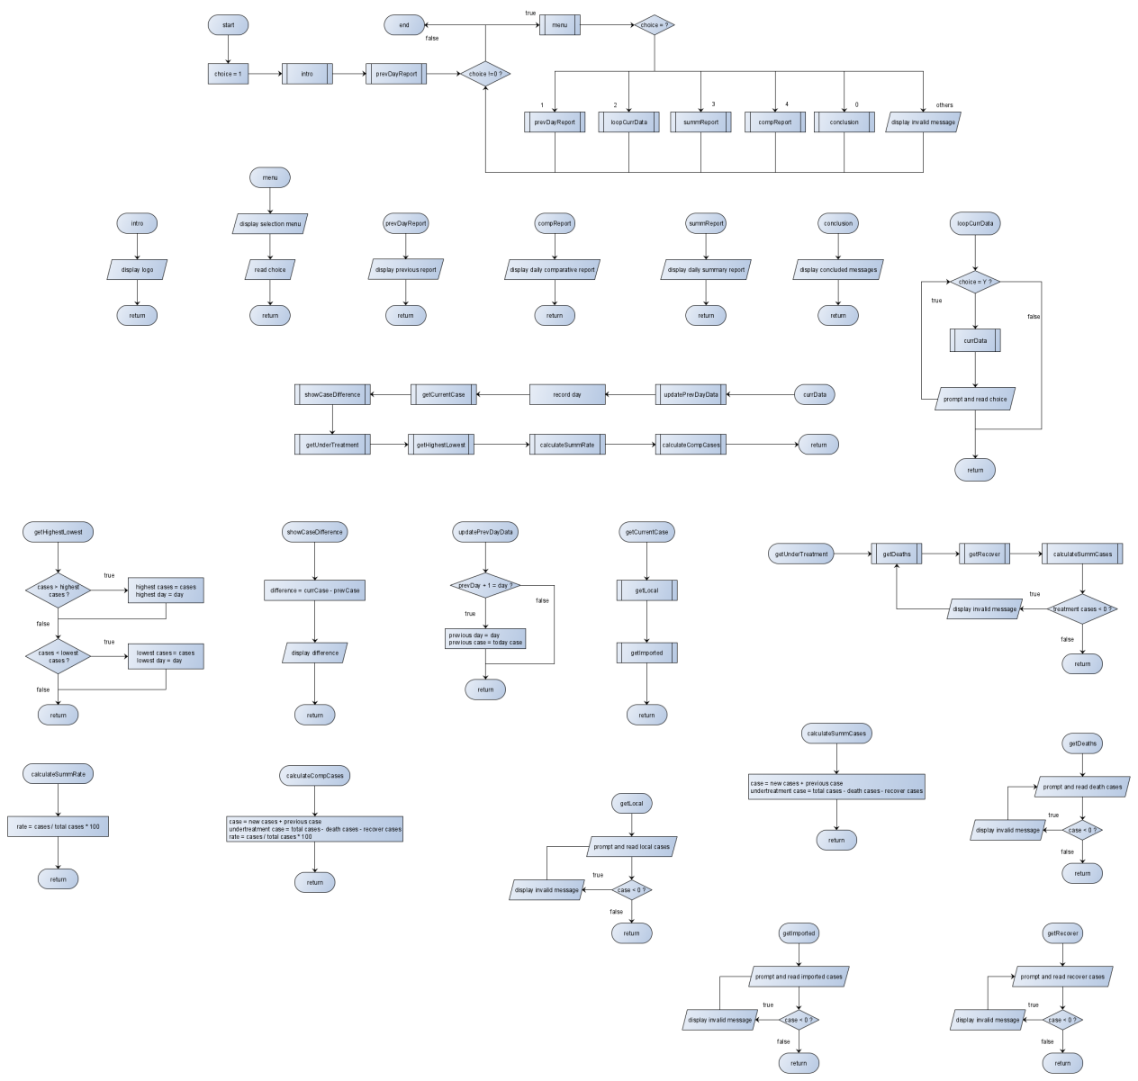

**Structure Chart**

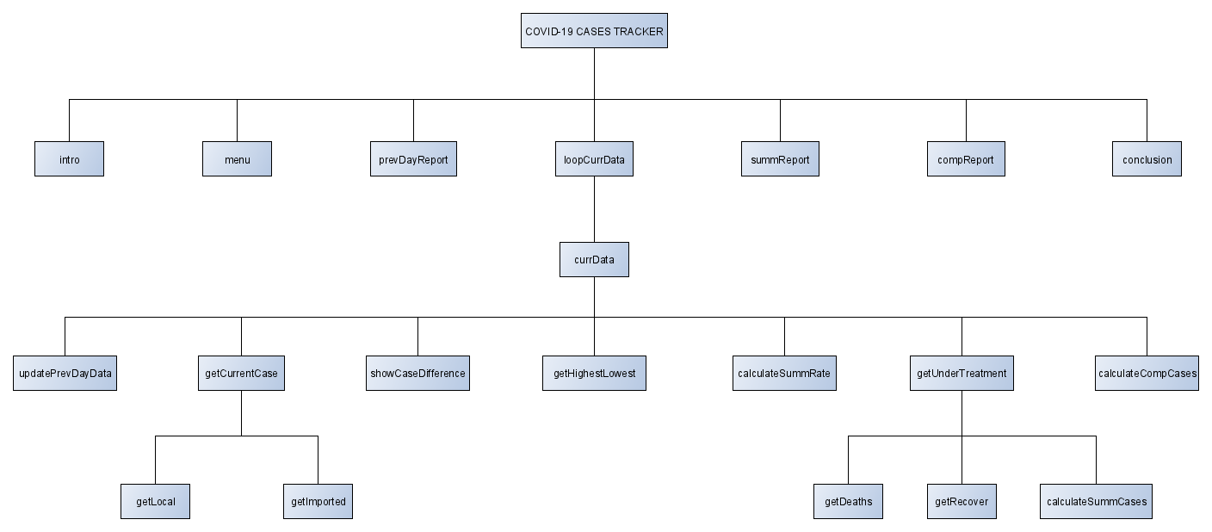

**Screenshot output**

1st scenario :

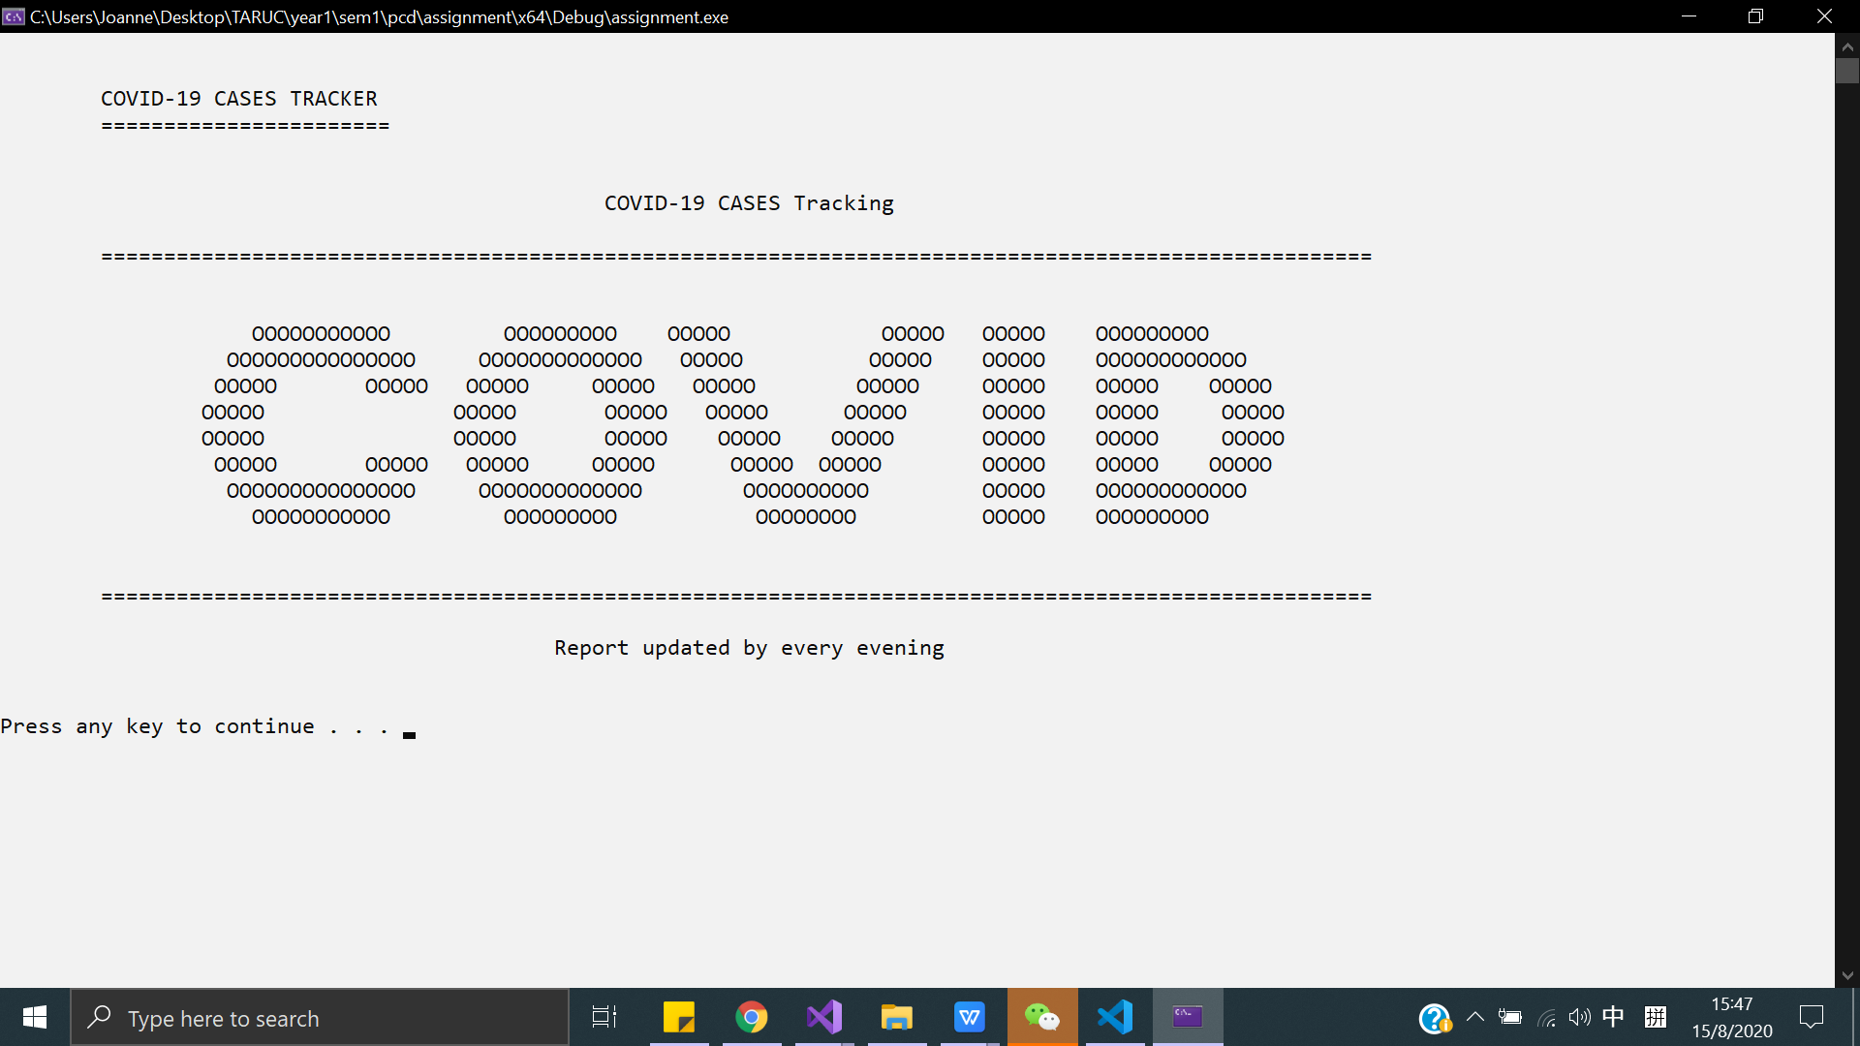

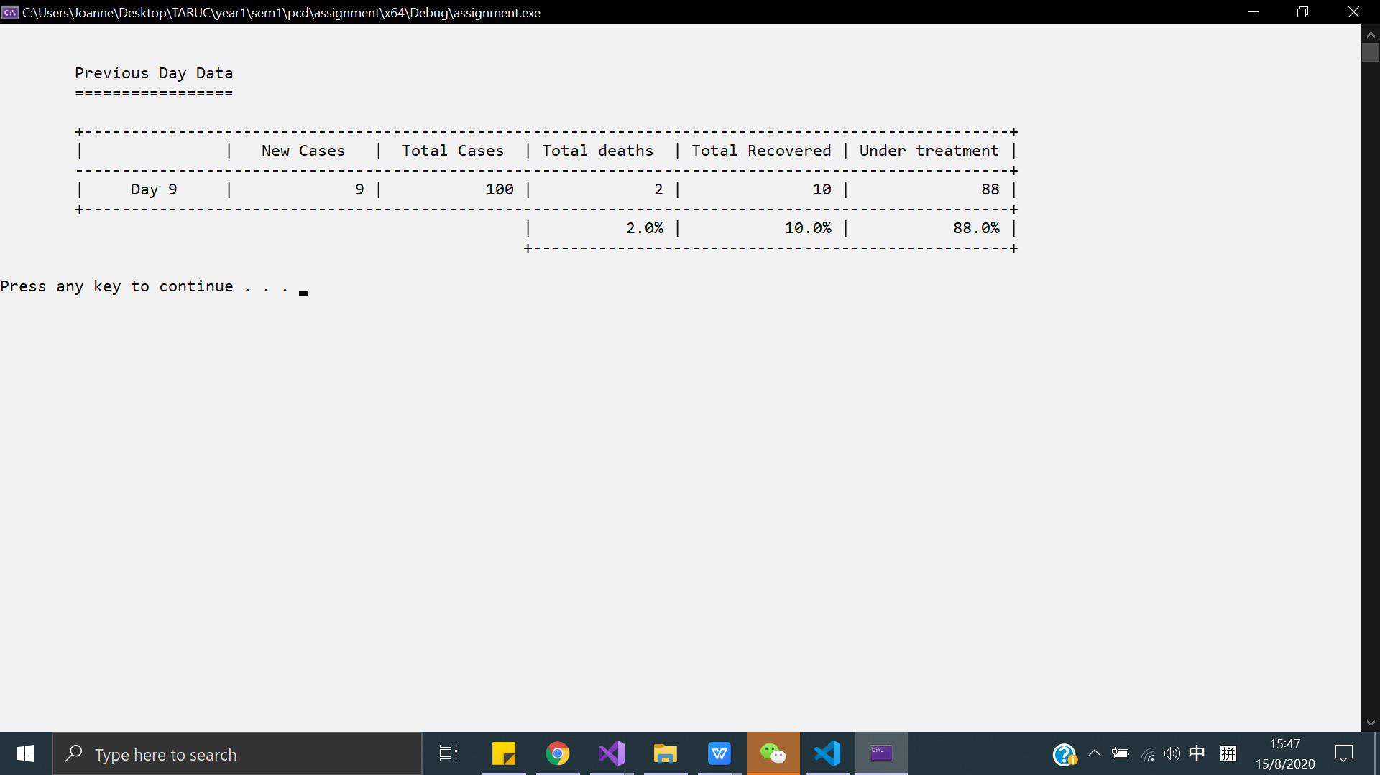

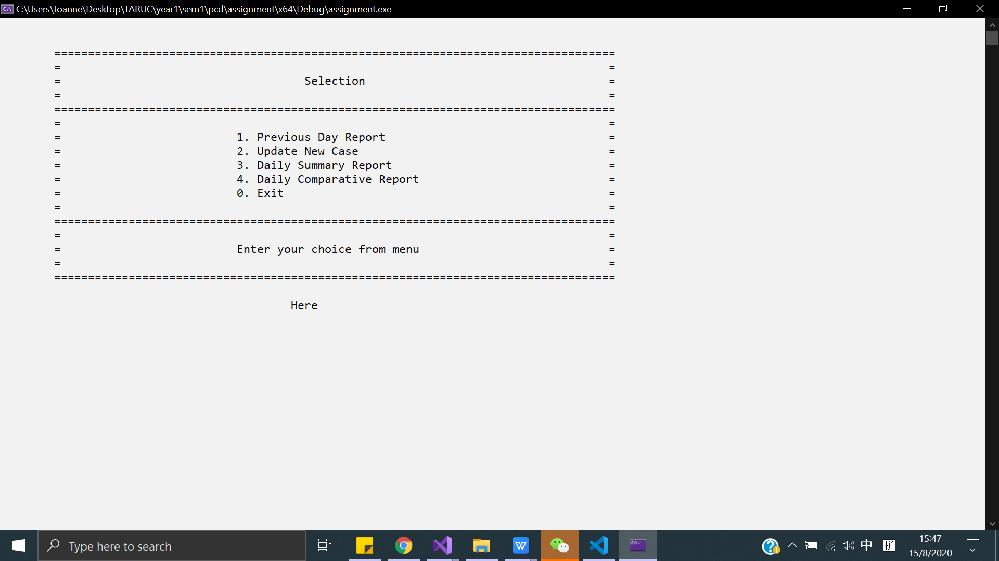

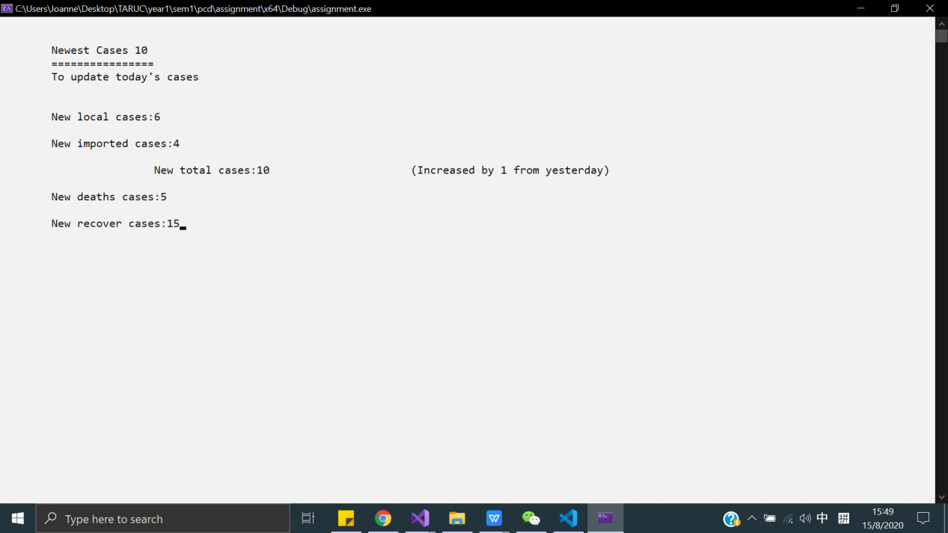

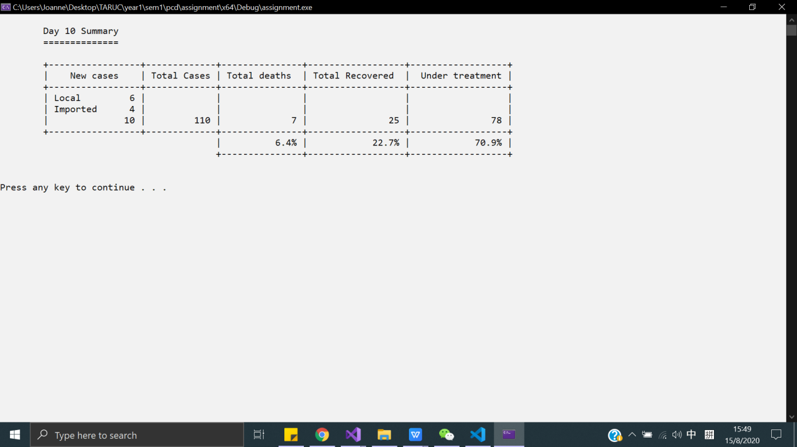

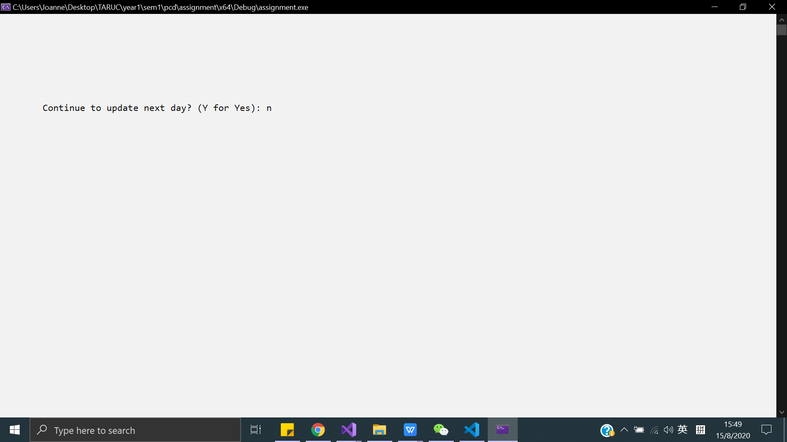

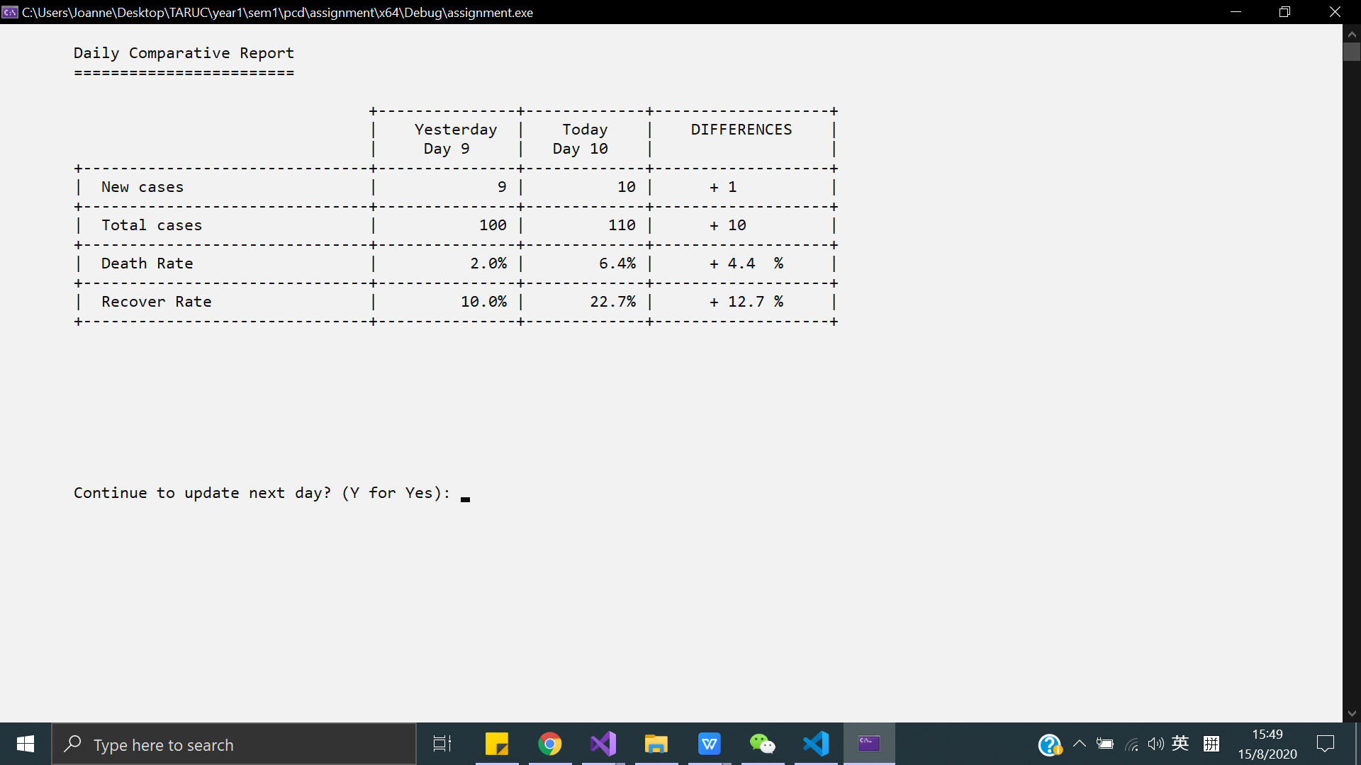

2nd scenario :







